**Interactive Segmentation using Graph Cuts**

**CS 578 Medical Image Analysis Final Project Report:**

Submitted By:

Ravindra Gadde

Raghu Yalamanchili

Date of Submission: 05/06/2011

**Introduction:**

In this project, we implemented Interactive Segmentation using graph cut based on the paper Yuri Boykov Marie –Pierre Jolly “Interactive Graph Cuts for Optimal Boundary & Region Segmentation of Objects in N-D Images”.

Here Interactive segmentation involves imposing both Hard Constraints (Indicate the pixels of the object region and the background region by the user) and soft constraints (Boundary and region properties of the segments).

Implemented algorithm is tested on both the Synthetic medical images (Brain MRI) and Non-medical images. The effect of adding noise to the original image on the actual segmentation is studied. This approach is compared with the other advanced techniques such as Grab cut, Lazy snapping.

**Approach and Implementation Details:**

Initially Graph G = {V, E} is formed by nodes V and edges E. Along with consideration the Pixels of the image as nodes ,two additional nodes S(source) for object and T (Terminal) for the background are considered.

To convert Image in to weighted graph (4-neighbourhood system is considered).As mentioned in the paper, for each pair of nodes an edge is formed called n-link. The weight function that is assigned for each n-link (Bp,q )is given below.

Bp,q is a measure of the similarity of image intensities at pixels p and q.

.

To incorporate user supplied initialization, a set of pixels in foreground (object) and Background are selected. These user supplied seeds are called Hard Constraints. Note that,here Interactive segmentation involves imposing both Hard Constraints (Indicate the pixels of the object region and the background region by the user) and soft constraints (Boundary and region properties of the segments).

Weights to the edges of the graph are assigned according to the algorithm specified in the aforementioned paper.

The initialized regions are used to define the histograms for the region based segmentation. Here negative log likelihood’s are used to define the weights

Rp(“obj”)=-ln Pr(Ip|O);

Rp(“bkg”)=-ln Pr(Ip|B);

Here Pr(Ip|O),Pr(Ip|B) are the intensity histograms of object and background respectively. The other implementation details are mostly derived from the paper.

Implementation of this interactive Graph cut segmentation uses the maxflow algorithm. We have used the mex implementation of this algorithm which is obtained from the Yuri boykov Maxflow Implementation.

**Results:**

The following are the results obtained by implementing the algorithm on Non-medical and Medical images.

Our implementation allows user to select 50 seeds for Foreground (Object) and Background each for this Yuri Boykov algorithm.

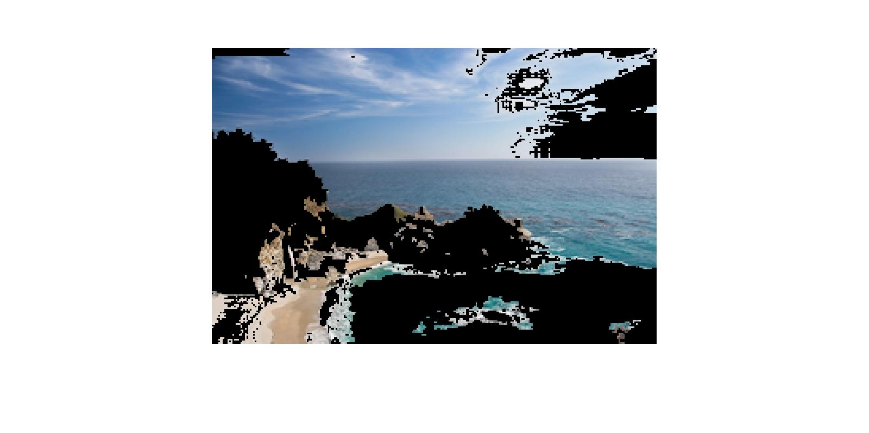

**Beach Image**

**Segmented Background Output image after the interactive initialization of foreground and** Background

**Original Image**

**Brain MRI image**

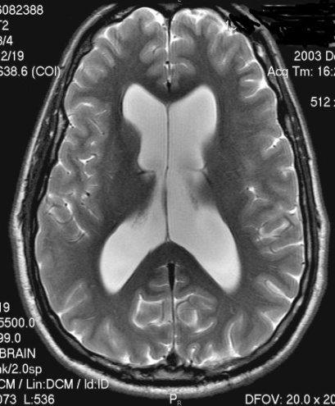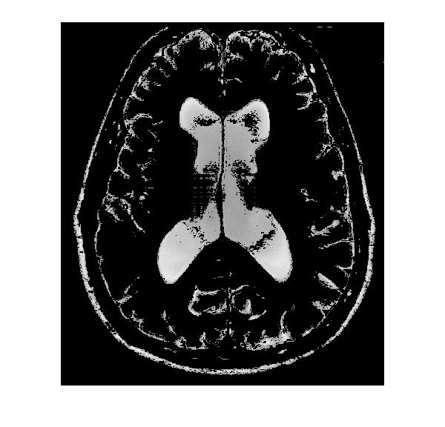

**Original Image**

**Segmented Foreground image using Yuri Algorithm**

**Effect of noise on segmentation:**

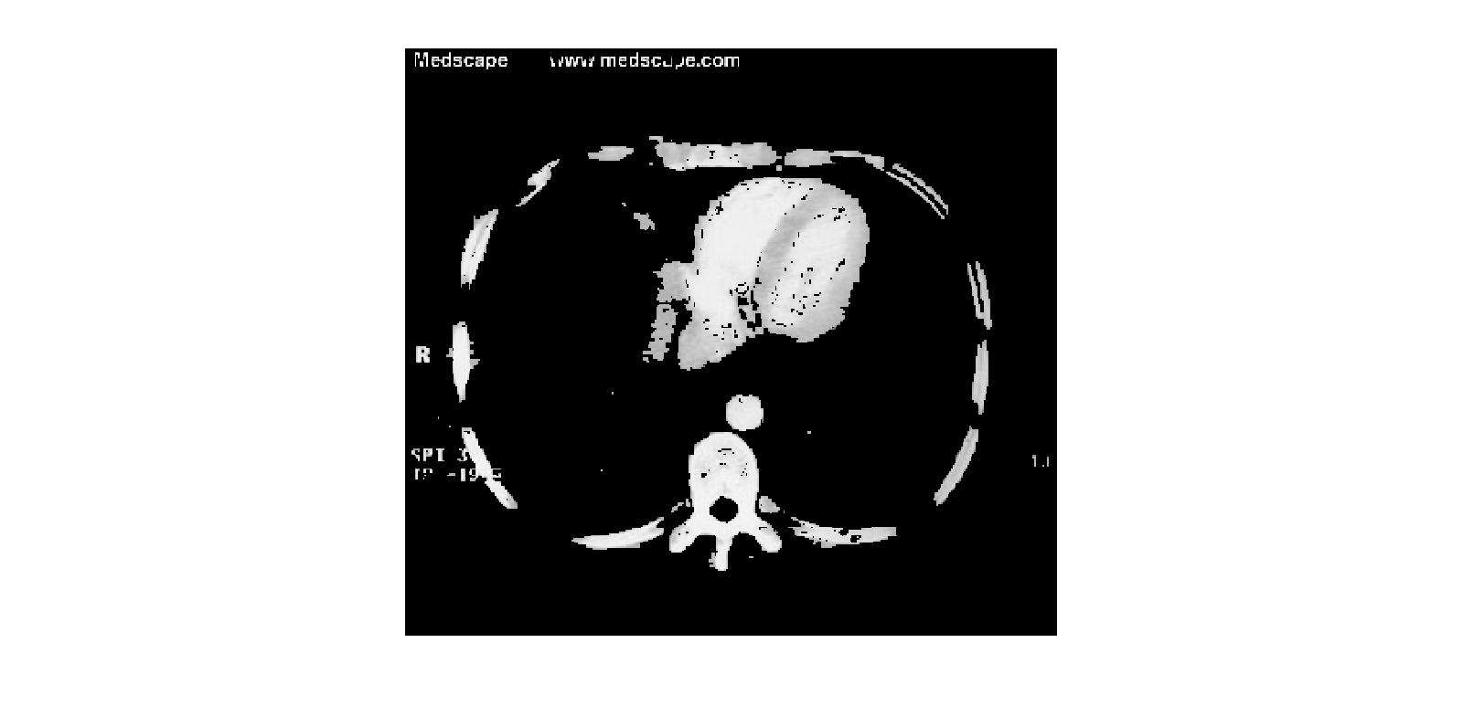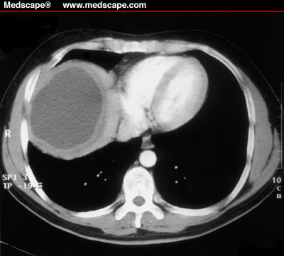

**Abdomen Image**

**Original Image**

**Segmented Foreground image using Yuri Algorithm**

To test the robustness of the algorithm we have added Gaussian noise and used the same seeds used for previous Brain MRI image and segmented. The segmented image is as shown below.

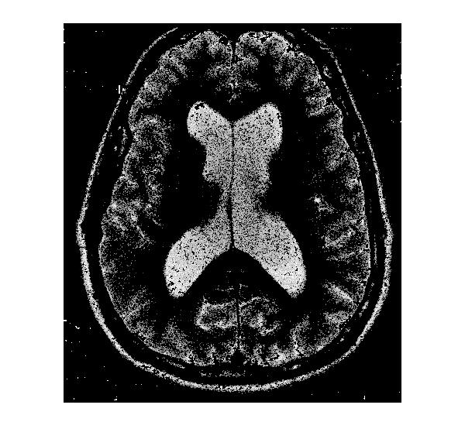

**Segmented Brain MRI image with noise**

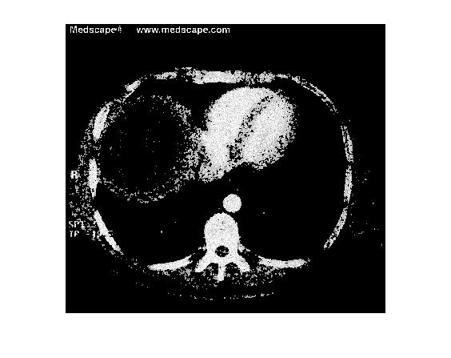

**Segmented Abdomen image with noise**

The effect of noise can be clearly seen in the image. The image segmented part contains more of background image than the previous image.

**Advancements:**

There are advanced segmentation algorithms in the literature which extends the concepts of graph cuts. Most prominent of them are Graph cuts and Lazy Snapping. Lazy napping is an interactive image cut out tool. Lazy Snapping separates coarse and fine scale processing, making object specification and detailed adjustment *easy*.

Grab Cuts extends graph-cut by introducing iterative segmentation scheme that uses graph-cut for intermediate steps. The user draws rectangle around the object of interest - this gives the first approximation of the final object/ background labeling. Then, each iteration step gathers Color statistics according to current segmentation, re-weights the image graph and applies graph-cut to compute new refined segmentation. After the iterations stop the segmentation results can be refined by specifying additional seeds, similar to original graph-cut.

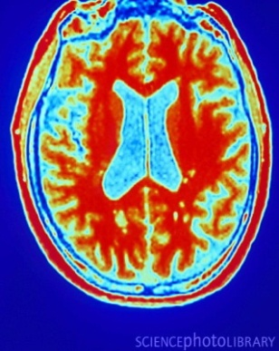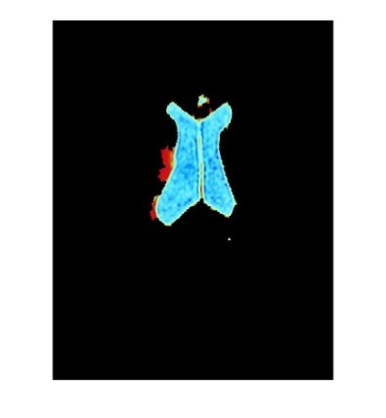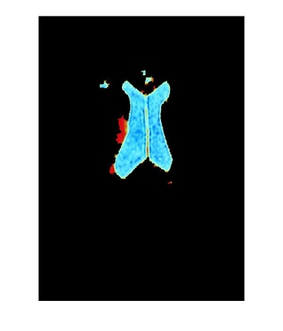

**Original Image**

**Segmented image using Grab cut**

**Segmented image using Grab cut + lazy snapping**

There is another relatively recent interactive segmentation algorithm called Grow cut. In grow cut, given a small number of user-labeled pixels, the rest of the image is segmented automatically by a Cellular Automaton. The process is iterative, as the automaton labels the image, user can observe the segmentation evolution and guide the algorithm with human input where the segmentation is difficult to compute. In the areas, where the segmentation is reliably computed automatically no additional user effort is required.

We have implemented Grab cut and Grabcut in combination with Lazy snapping from the work of Mohit gupta and Krishnan Ramnath (Carnegie Mellon University)called Segmentation tool box for comparison purposes. Results are shown below.

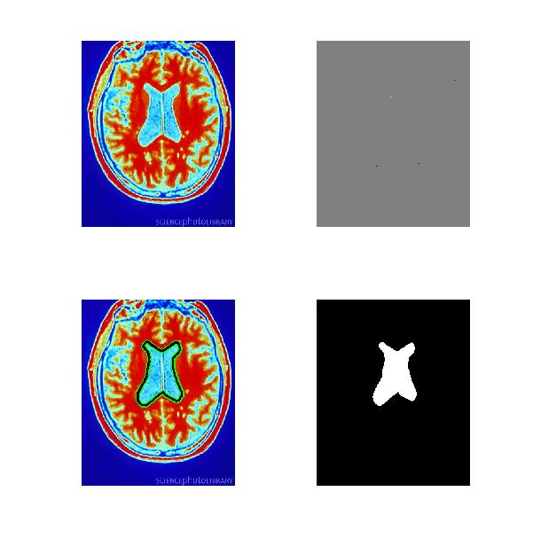

**Original Image**

**Seeds**

**Segmented Image represented with boundary**

**Segmented Image**

**Inferences:**

In this project we have implemented Graph cuts based on yuri Boykovs Paper using Maxflow Algorithm. The Effect of noise on the output segmentation is studied .Also, the results obtained by implementing advanced Algorithms to the Graph cuts like Grab cut and Lazy snapping are presented.

**References:**

1. Y.Boykov,M.P Jolly,*Interactive Graph Cuts* for Optimal Boundary & Region Segmentation of Objects in N-D Images,ICCV 2001.
2. *Rother et.,al “GrabCut” — Interactive Foreground Extraction using Iterated Graph Cuts,2004*
3. *Y.Li et.,al lazy Snapping,SIGGRAPH,2004*
4. Vladimir Vezhnevets et.,al“GrowCut” - Interactive Multi-Label N-D Image Segmentation By Cellular Automata.
5. M.Gupta et.al,“Segmentation tool”,CMU.